Guided Practice Report
Before completing this guided practice report, you should have completed the associated procedure.

Screenshots
After you have completed the procedure for the guided practice, add your screenshots below.
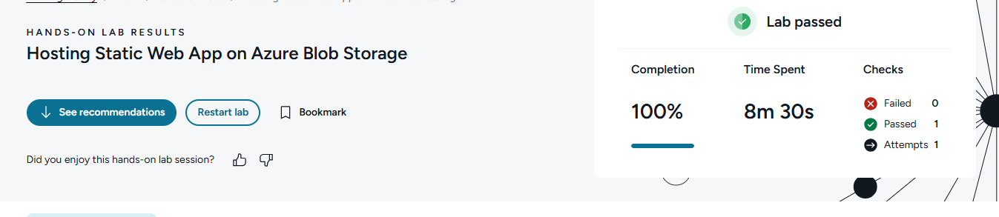

Reflection Questions
After you have completed the procedure for the guided practice, provide your answers to the reflection questions here.
Why were you unable to access the Azure Primary endpoint URL (web page) on your first attempt?
I couldn’t access the Azure Primary endpoint at first because the web content had not been uploaded/configured correctly yet, so the endpoint had nothing viewable to serve.

How did the tasks required to make your web content viewable with Azure differ from that required inside AWS?
In Azure, I had to enable/configure static website hosting and upload content to the special $web container. In AWS, I uploaded files to an S3 bucket and adjusted bucket/static website permissions so the page could be publicly viewed.

